Learning Plan
Class Title:

Teaching Artist:

Grade(s)/Age(s):.

School/Location:

Description:
Tree of Life. Examination of the ideas surrounding the Tree of Life. A popular symbol used in many different cultures. Below are some themes that run through various cultural interpretations of the Tree of Life.
A Connection to Everything: All things are connected through branches and roots
Ancestry, Family: the Tree of Life is a way to represent those who came before you and those that will come after you
Immortality, Rebirth, Nourishment: Trees lose leaves which grown back as buds in the spring. Fallen leaves nourish the soil which helps the roots grow.
Peace: Tree as symbol of calmness. Provides a safe space for those in need of shelter.

Materials & Space:
Paper, pencil, coloring pencils or watercolors, (alternate method: use washable markers then paint over them with water for “watercolor effect”)

Big Idea:
The Tree of Life is an eternal symbol. Today it means something to you that may be different in a month or year.

Student Learning Assessment
Learning Objectives  What I want my students to know/understand and be able to do. | Assessment Criteria  What I will observe in my students – traits that can be seen and/or heard.
1. design personal Tree of Life. | 1. students can articulate what their Tree of Life means to them
2. use personal symbols to represent what is important to. (Things in the tree besides leaves and branches.) | 2. articulate what individual symbols mean
3. Students can make a roughly symmetrical design | 3. Tree shows (roughly) bilateral symmetry and vertical symmetry

Art terminology:
Symmetrical: made up of similar shapes facing each other
Motif: distinct feature or repeating idea
Symbol: an object representing something else
Opening Ritual:
Hook:
Warm Up: Choose 1
- stand up. imagine you are a tree. Your body is the trunk. Reach with your arms. Grow a branch, grow another branch. Imagine the leaves, what shape are your leaves? Grow roots, imagine stretching your feet under the ground. Where do they grow?

- look at this drawing by Minnie Evans. Minnie Evans was an African American artist. She lived her entire life in North Carolina. She was completely self taught. That means she didn’t take art classes or study art anywhere. What do you notice about her painting? What symbols do you see? Painting below, or https://learn.ncartmuseum.org/artwork/the-tree-of-life/ 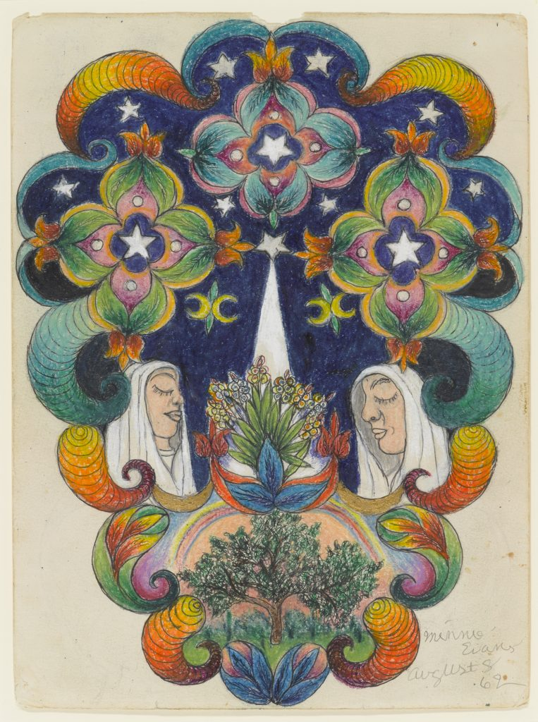

- Show painting by Seema Kohli. She is from India. Known for colorful paintings, themes bout women, growth, rebirth. What do you see in this painting? What shapes or designs do you see?

https://www.artsy.net/artwork/seema-kohli-tree-of-life-acrylic-and-ink-on-canvas-gold-and-silver-leaf-red-green-by-seema-kohli-in-stock

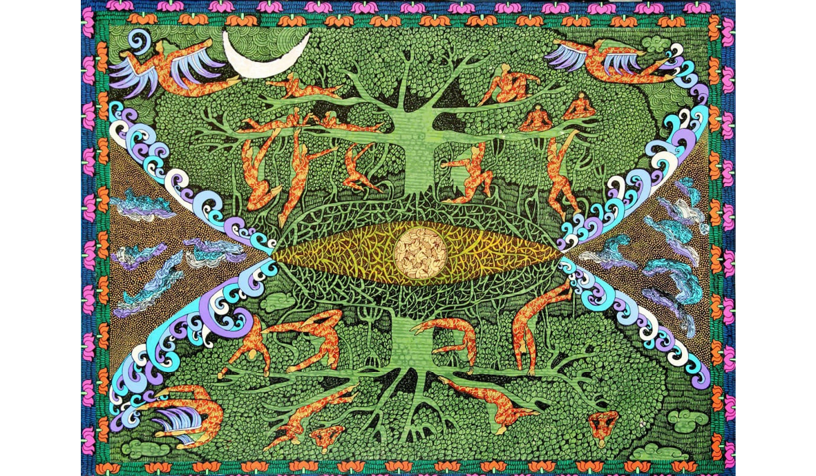

Prep Activity:
on one side of your paper draw a tree. Draw another tree, draw another tree, draw another tree. What are the parts of a tree? Did anyone draw roots? What does a tree mean to you? Are there any symbols you can think of that will convey that message? Write down those symbols.

Main Activity:
- Fold paper in half, fold in half again. Paper should have 4 squares, 2x2
- With a pencil start to draw a trunk, with the bottom of the trunk at the center point of the paper.
- On one half draw a branch. How thick is the branch? Draw another branch on the same side. Is the second branch thinner?
- On the other half try to draw a mirror image of the branches on the other side. It doesn’t have to be exactly the same.
- When you have the tree done notice the shape of the tree canopy.
- On the bottom half of the paper draw the roots. The shape of the roots will be similar to the tree shape.
- Think about what you want your tree to mean. What symbols go in your tree?
- Add symbols.
- Add color with color pencils or watercolor.

Reflection: Share out….what does the Tree of Life mean to you?

TREE (OF LIFE) – 6 Artists to teach The Tree of Life with besides Gustav Klimt (Austria), and Mercedes Lagunas (Spain)

Adrian Luis Gonzales – b. 1939, Mexico
https://www.artedelavidatucson.com/store/p24/Adrian_Luis_Gonzalez_Tree_of_Life.html
https://en.wikipedia.org/wiki/Adri%C3%A1n_Luis_Gonz%C3%A1lez

Ai Weiwei – b. 1957, China
https://www.sculpturenature.com/en/in-the-shade-of-trees-1-ai-weiwei-the-tree-recomposed/

Seema Kohli – b. 1960, India
https://laasyaindianart.medium.com/interview-with-contemporary-indian-artist-seema-kohli-470bfadb2b3b
http://www.artnet.com/artists/seema-kohli/the-tree-of-life-i-ii-set-of-two-yN27P9VlBkRiE6pc7pUWtg2

Marcelino (Balugto) P. Necosia Jr. - b. 1984, Philippines
http://www.imagomundiart.com/artworks/marcelino-balugto-p-necosia-jr-tree-life/

The mosaics artists of Madaba, Jordan
https://www.connectthecultures.com/jordanian-women-create-mosaics-madaba/

Abel Rodríguez b. 1944, Colombia
https://www.tropenbos.org/news/the+tree+of+life+and+abundance
https://www.documenta14.de/en/artists/13538/abel-rodriguez

Minnie Evans, 1892-1987, North Carolina, African American
https://learn.ncartmuseum.org/artwork/the-tree-of-life/
https://en.wikipedia.org/wiki/Minnie_Evans

Other Resources:

https://en.wikipedia.org/wiki/Tree_of_life
https://aatfweb.org/2019/11/16/tree-of-life-an-interreligious-dialogue-through-the-modern-art/
https://festival.si.edu/2002/the-silk-road/the-tree-of-life/smithsonian
http://www.luggagestoregallery.org/2019/04/post-colonial-survival-kit/
https://www.artedelavidatucson.com/store/c6/trees-of-life
https://britishmuseum.withgoogle.com/object/tree-of-life

